L.O. To describe a character from the text an infer meaning
What have you discovered about the Gruffalo as you have been reading through the play? Write some of the describing words and phrases around the Gruffalo, which describe its appearance and behaviour, from the text. What can you infer from the descriptions of the Gruffalo? E.g. He has terrible teeth. The writer may be inferring that he doesn’t brush his teeth.
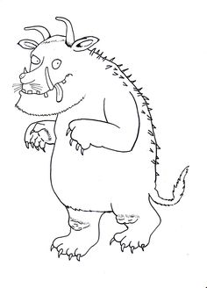
What do his knobbly knees infer?

